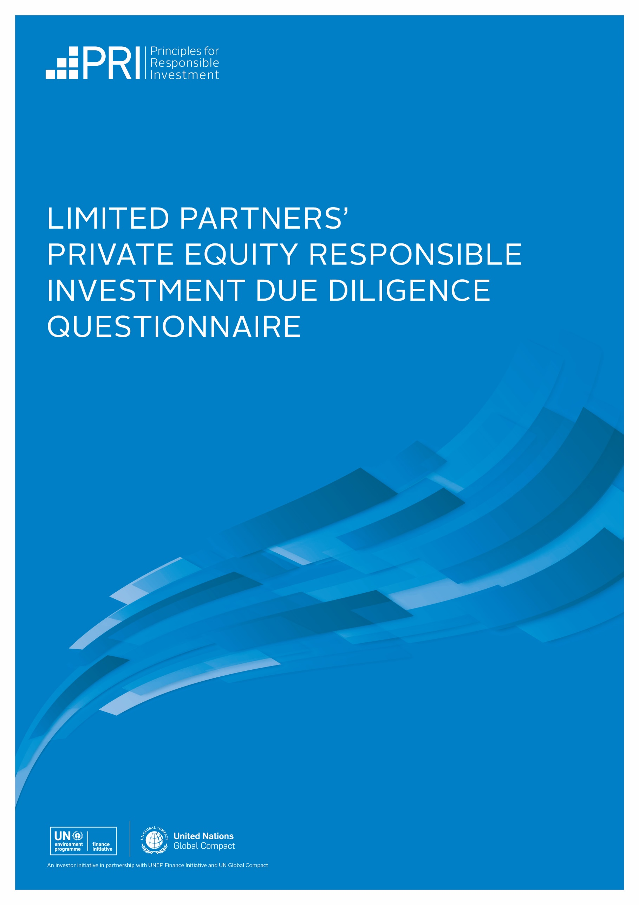

Limited Partners' PRIVATE EQUITY responsible investment due diligence questionnaire

The Limited Partners’ (LP) Private Equity Responsible Investment Due Diligence Questionnaire (DDQ) has been developed to help investors understand and evaluate a general partner's (GP) processes for incorporating material environmental, social and governance (ESG) risks and opportunities into their investment practices and to understand where responsibility for doing so lies.

This DDQ forms part of the Institutional Limited Partners Association's (ILPA) DDQ. It is also designed to complement the PRI's Reporting Framework, particularly the private equity module. Where a DDQ question maps in a material way to a Reporting Framework question, the relevant indicator(s) is provided.

The DDQ is divided into seven sections:
- Policy
- Fundraising
- Pre-investment
- Post-investment
- Reporting & disclosure
- Climate change
- Additional information

WHY USE THE DUE DILIGENCE QUESTIONNAIRE?
A questionnaire can never replace the dialogue between manager and investor: this DDQ is designed to act as a starting point for such dialogue by providing a baseline list of questions that LPs can ask GPs during the fundraising process.

LPs may consider supplementing this DDQ with additional questions. However, they should consider the importance of those questions versus the additional administrative burden placed on GPs. They are encouraged to:
- assess DDQ responses in the context of the GP’s size, experience, and resources; and
- use any opportunities for improvement that they identify as the basis for engagement, either pre-or post-commitment.

guidance for completing the DDQ

general guidance
GPs are encouraged to complete this DDQ as part of their general preparations for launching a fundraise and include it in their data rooms as standard.

They should make the scope of their responsible investment activities clear within their DDQ responses, for example, by specifying whether a response applies across all strategies, select strategies, or a select fund.

GPs that are PRI signatories should provide their latest PRI public Transparency Report alongside their responses to the LP Private Equity Responsible Investment DDQ.

reviewing fund documentation
During the initial stages of due diligence, an LP may review the GP’s Private Placement Memorandum (PPM), Offering Memorandum, or any other introductory marketing materials to establish whether their fund addresses ESG considerations.

If the LP is undertaking due diligence on a PRI signatory, they are strongly encouraged to review the GP’s latest public PRI Transparency Report on the PRI website. LPs are also encouraged to request permission from the GP to view their private PRI Transparency and Assessment Reports.

An LP may also wish to ask the following questions:

- Does the fund have a formal policy to exclude investments in any particular industries, geographies, or business models, based on any ESG criteria?
- If the LP has an exclusions policy, does the fund’s investment strategy potentially include investments that would conflict with this policy? If so, would the GP be willing to ensure that the LP’s capital is not used for such investments?
- Does the fund target sectors or geographies that have specific ESG risks and/or opportunities that the GP plans to pay particular attention to during the investment analysis and/or due diligence process?

INVESTMENT STRATEGIES
Private equity is a diverse asset class that includes venture capital, growth equity, and buyouts, as well as a range of indirect strategies such as fund of funds and secondaries. Different sub-asset classes and funds will have different exposures to ESG-related risks and opportunities, while their approaches to ESG incorporation will also vary significantly.

An LP should analyse DDQ responses in the context of the GP’s investment strategy and discuss how their ESG incorporation approach is influenced by various factors, such as:

- whether they make minority or control investments;
- the growth stage of target companies;
- indirect investments such as fund of funds.

control investors
The entire DDQ is relevant to control investors.

minority investors
Minority investors with board seats and larger shareholdings may be able to influence the strategy and operations of their underlying portfolio companies. Other minority investors may not be able to do this – those with smaller shareholdings, for example, or GPs that do not have a board seat or that only have observer rights.

This may impact the extent to which minority investors can address certain questions in the Post-investment and Reporting & disclosure sections of this DDQ, compared with control investors. However, the PRI encourages minority investors to provide all relevant information on how they ensure ESG risks and opportunities are appropriately managed within the degree of influence they have over portfolio companies and lead investors in co-investment situations.

venture capital
Venture capital investors make minority investments in early-stage companies, from pre-seed to later stage growth-equity investments. As with other minority investors, their potential influence over portfolio companies will vary. Still, venture capital GPs are encouraged to tailor ESG policies and practices to the risks and opportunities of the sector(s) they invest in and the stage of capital they typically provide.

FUNDS OF FUNDS (including secondaries)
When investing in a fund of funds, LPs should seek assurance that the GP has a thorough process in place to assess and monitor the responsible investment approach of the underlying funds.

An LP could ask the fund of funds GP to complete this DDQ during fundraising (noting that some questions might not be applicable, such as 4.1, 4.2, 4.3, 4.7, and 4.8). Fund of funds managers are encouraged to use this DDQ for their ESG due diligence of underlying funds.

climate change
The DDQ has a dedicated section on climate change.

In addition to this, where climate-related information is relevant to other DDQ questions, this has been highlighted in the guidance notes. This guidance has been included in questions identified as aligning with the four pillars of the Task Force on Climate-related Financial Disclosures (TCFD).

ddq questions

Policy

Understanding your ESG-related policies, governance, and oversight.

  - [PGS 1, PE 1] Do you have a responsible investment policy?
If so, provide a copy or a link if publicly available, state when it was implemented, whether it has been fully implemented, what the process for reviewing and updating it is, and describe any changes you have recently made or plan to make. If you do not have a responsible investment policy, explain why not.
  - What international standards, industry (association) guidelines, reporting frameworks, or initiatives that promote responsible investment practices have you committed or contributed to?
[PGS 17,18] Ensure that any relevant commitments to standards, guidelines, frameworks, or initiatives relating to climate change are also included.
  - [PGS 11, 11.1, 12] How are (i) oversight responsibilities and (ii) implementation responsibilities for ESG incorporation structured within your organisation?
List the persons involved, describe their role, position within the organisation and how they are qualified for this role. Describe any external resources you may use.
Please also include any relevant discussion around how the management and oversight of climate-related risks and opportunities are structured within your organisation.
  - [PGS 13, 14] To what extent, if any, are ESG objectives incorporated into performance reviews and compensation mechanisms at your firm?
Describe how ESG objectives are defined and measured and to which positions they apply, e.g. investment professionals/ESG teams.
  - How do you equip your investment professionals and other staff to understand and identify the relevance and importance of ESG risks and opportunities in investment activities?
If you provide training, assistance and/or additional resources, please describe them. This should include how often these are delivered, by whom, and to whom.

Fundraising

Establishing your ESG commitments within fund documentation.

  - [PE 2] What formal ESG commitments have you made or do you plan to make in the Limited Partnership Agreement (LPA), side-letters, or other constitutive fund documents?
Describe any formal ESG commitments you have made or plan to make related to this fundraise. Please also share sections of your PPM or other marketing materials relevant to ESG commitments.

pre-investment

Understanding how you identify material ESG risks and opportunities in your investments.

  - [PE 3, 3.1, 5] How do you conduct (i) ESG materiality analysis for potential investments and (ii) due diligence on potentially material ESG risks and opportunities?
(i) Explain your process, give two to three examples of ESG risks and opportunities identified during screening as material to portfolio companies in your most recent fund, and disclose any tools, standards and data you use to determine which ESG risks and opportunities are material.
(ii) Please illustrate your ESG due diligence process using one to two examples from a recent fund.
[PGS 41, 41.1, 43, 44] In addition, please include any relevant discussion around which frameworks and tools you use in due diligence to identify and assess climate transition and physical/adaptation risks and opportunities, including the use of scenario analysis.
  - [PE 4] How do ESG risks and opportunities affect the selection of your investments?
Explain using one to two examples from a recent fund. Did they help identify risk management or value creation opportunities, lead to the abandonment of certain investments, impact the valuation of investments, or affect other deal terms?
[PGS 41.1, 44] In addition, please include any relevant discussion around how climate-related risks and opportunities affect your investment strategy or investment selection.
  - How are ESG risks and opportunities reported to, considered, and documented by the ultimate decision-making body, such as the investment committee?
Describe the process you have in place and illustrate this with a recent fund example.
3.4 How are ESG-related considerations integrated into deal documentation such as Shareholders' Agreements during deal structuring?
Describe the process you have in place and illustrate this with a recent fund example.

post-investment

Understanding how you contribute to your portfolio companies' ESG risk mitigation and value creation efforts.

  - [PE 8, 11] Do you create ESG-specific value creation plans or incorporate ESG issues into regular value creation and/or 100-day plans?
If so, describe how those are defined, implemented, and monitored and provide an example from a recent fund.
  - [PE 12, 12.1] How do you ensure that adequate ESG-related competence and resources exist at the portfolio company level?
Describe one or two initiatives taken as part of your ESG competence-building efforts in prior funds, and indicate which function, position, or role is generally given ESG responsibilities at portfolio companies.
  - How do you use your board seats or interaction with the board to monitor, influence, and incentivise the portfolio company's management of ESG risks and opportunities?
This could include how ESG objectives are linked to compensation mechanisms at the portfolio company level.
[PGS 41.1, 44] Ensure that any relevant discussion around the management of climate-related risks and opportunities is also included.
  - [PE 9] How do you contribute to the management of material ESG-related risks and opportunities during the holding period of your investments?
Provide two to three examples from a recent fund highlighting how you directly contributed to any initiatives. For example, those where you worked with management to identify issues and instigated further action such as implementing relevant policies, or those you supported your portfolio company to achieve.
[PGS 41.1, 44] In addition, please include any relevant discussion around the management of climate-related risks and opportunities.
  - [PE 6, 6.1] Do you monitor and track ESG key performance indicators (KPIs) for your investments?
If so, how do you identify material KPIs, and which frameworks do you use, if any? Provide details of the KPIs you have tracked in prior funds.
[PGS 45] In addition, please include a discussion of any climate physical or transition risk-related metrics.
  - [PE 7, 7.1] How do you use the identified ESG KPIs?
Please indicate if you set targets for them or benchmark performance against comparable companies. If so, how do you do this, and how do you support portfolio companies to meet the targets?
[SO 2, SO 3] In addition, please include a discussion of KPIs related to climate change risks and opportunities.
  - [PE 13] How do you incorporate ESG considerations into preparations for exit?
If you do not incorporate ESG considerations into preparations for an exit, explain why.
  - How do you seek to determine whether your approach to ESG risks and opportunities has affected your investments' financial performance?
Provide one or two examples from a recent fund describing how you assess financial outcomes in the investment lifecycle related to ESG incorporation. If you do not measure the financial implications of your ESG incorporation activity, please qualitatively explain the expected added value associated with your ESG incorporation approach.
  - [PGS 47, 47.1, 47.2] Do you identify sustainability outcomes (the positive and negative real-world outcomes) related to investees’ operations, products and services?
If so, disclose any frameworks or tools you use to identify these (e.g., SDGs, Impact Management Project (IMP), The United Nations Guiding Principles on Business and Human Rights (UNGPs), OECD guidelines on multinational enterprises).

reporting & disclosure

Understanding how LPs can monitor your ESG performance and ensure the fund is operating within agreed-upon policies and practices, including disclosing material ESG incidents.

  - [PE 14] How do you report and evidence progress on ESG performance, including data and targets, to LPs?
Provide samples of ESG-related disclosures from an earlier fund. If past disclosures are not available, please state whether you would consider introducing ESG-related disclosures for your next fund.
[PGS 45, 46] In addition, please include a discussion relevant to climate change risk metrics and targets.
  - Is the management of ESG risks and opportunities included on your Limited Partners Advisory Committee and Annual Investor Meeting agenda?
If so, provide one or two examples of included issues at the portfolio company or fund level. If not, explain why not.
  - What is your approach to managing material ESG incidents and disclosing them to your limited partners?
Provide your definition of what constitutes a material ESG incident and, through an example, explain the steps you have taken to manage past incidents and prevent future occurrences. Please also state whether there have been any at your firm or portfolio companies within the last three years.

climate change

  - How do you measure and report the greenhouse gas (GHG) emissions associated with your investments?
[PGS 46] Describe the methodology used. If you do not measure and report GHG emissions, please explain why not, or the current status of your efforts.

  - Describe any climate commitments or targets your firm has made, or actions your firm employs, to assess and address climate-related risks and opportunities not otherwise covered in this document.
Describe any climate-/emissions-related KPIs and targets you have set with your portfolio companies or committed to as a firm.
Ensure that, if relevant, you have responded to the guidance on climate-related risks and opportunities above in questions 1.2, 1.3, 3.1, 3.2, 4.3, 4.4, 4.5, 4.6 and 5.1, and add any further discussion that might be relevant here. If you have not disclosed any climate-related information, please explain why not.
  - If you have reported in line with the TCFD recommendations, please provide a copy of your TCFD report.
[PGS 17] Please indicate if you plan to report in future. If you have not reported in line with the TCFD recommendations, please explain why not.

ADDITIONAL INFORMATION

  - If applicable, describe how your approach to ESG incorporation addresses specific ESG topics or practices not otherwise covered in this document.
This could include issues such as human rights and related frameworks such as the UNGPs, diversity, equity and inclusion, or biodiversity, how you link ESG outcomes to loan facilities, incorporating ESG outcomes into staff carry incentives, or development of an industry-wide ESG initiative, etc.
  - How do you manage your management company's (i.e. your own business') internal ESG risks and opportunities?
Describe the initiatives you have developed and/or will develop to improve your firm's internal ESG performance e.g. to improve investment team diversity.
If you are completing this PRI DDQ as a standalone document outside of the ILPA DDQ, please include a separate response to the Diversity, Equity and Inclusion section of the ILPA DDQ and ILPA's Diversity Metrics Template. These can be found at https://ilpa.org/due-diligence-questionnaire/

acknowledgements
We would like to thank the following signatories for their feedback and contributions to this DDQ:

- AlpInvest Partners – Maaike van der Schoot
- AP6 – Anna Follér
- Apax Partners – Ellen de Kreij
- APG – Keren Raz
- Apollo Global Management – Robert Esposito
- Ardian – April Tissier
- Ares Management – Adam Heltzer
- Bridgepoint – James Holley
- California Public Employees’ Retirement System (CalPERS) – James Andrus
- California State Teachers' Retirement System (CalSTRS) – Nicholas Abel
- CDC Group – Zinhle Tshabalala
- Cinven – Vanessa Maydon
- CVC Capital Partners – Chloë Sanders
- European Investment Fund (EIF) – Uli Grabenwarter
- HarbourVest Partners – Natasha Buckley
- Harvard Management Company – Michael Cappucci
- Helios Investment Partners – Phil Davis
- Hong Kong Monetary Authority (HKMA) – Kim Chong and Alan Mak
- Intermediate Capital Group (ICG) – Eimear Palmer
- Investindustrial – Serge Younes
- KKR – Elizabeth Seeger
- LACERA – Scott Zdrazil
- Neuberger Berman – Jennifer Signori
- New Mountain Capital – Ignacio Sarria
- Oak Hill Capital Partners – Lee Coker
- Permira – Adinah Shackleton
- Stafford Capital Partners – Silva Deželan
- StepStone Group – Dawn Powell
- TPG & Y Analytics – David Frank and Jessica Fay
- Universities Superannuation Scheme (USS) – Helen Hopkins
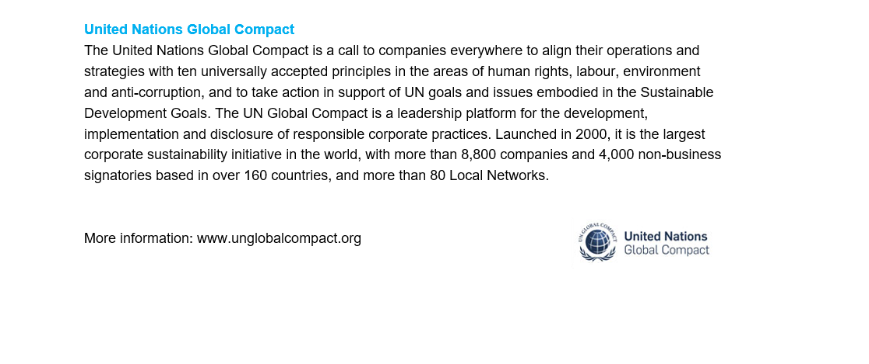
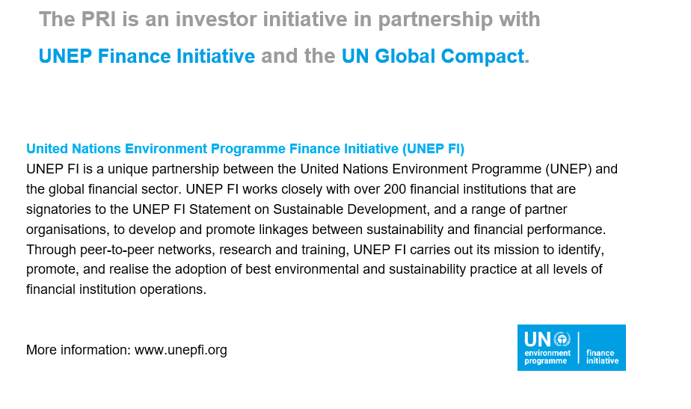
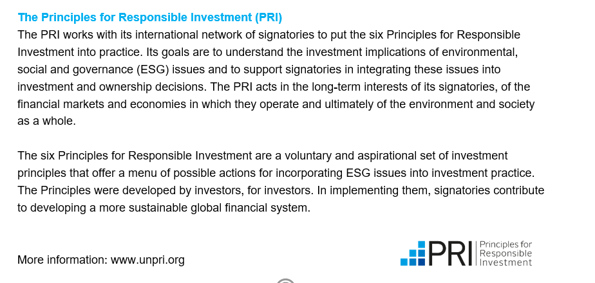

Sustainability outcomes are the intended and unintended, positive and negative effects that the businesses in which you invest have on the world around them. Examples of negative outcomes include biodiversity loss resulting from construction in an open space, human rights violations linked to dual-use technology, stress on water systems due to high water consumption. Examples of positive outcomes include reduction of waste through circular economy initiatives, upskilling programs successfully retraining employees for the digital economy, development of green products or services (with evidence of positive sustainability impact), inclusive products and services that address issues of systemic racism.

