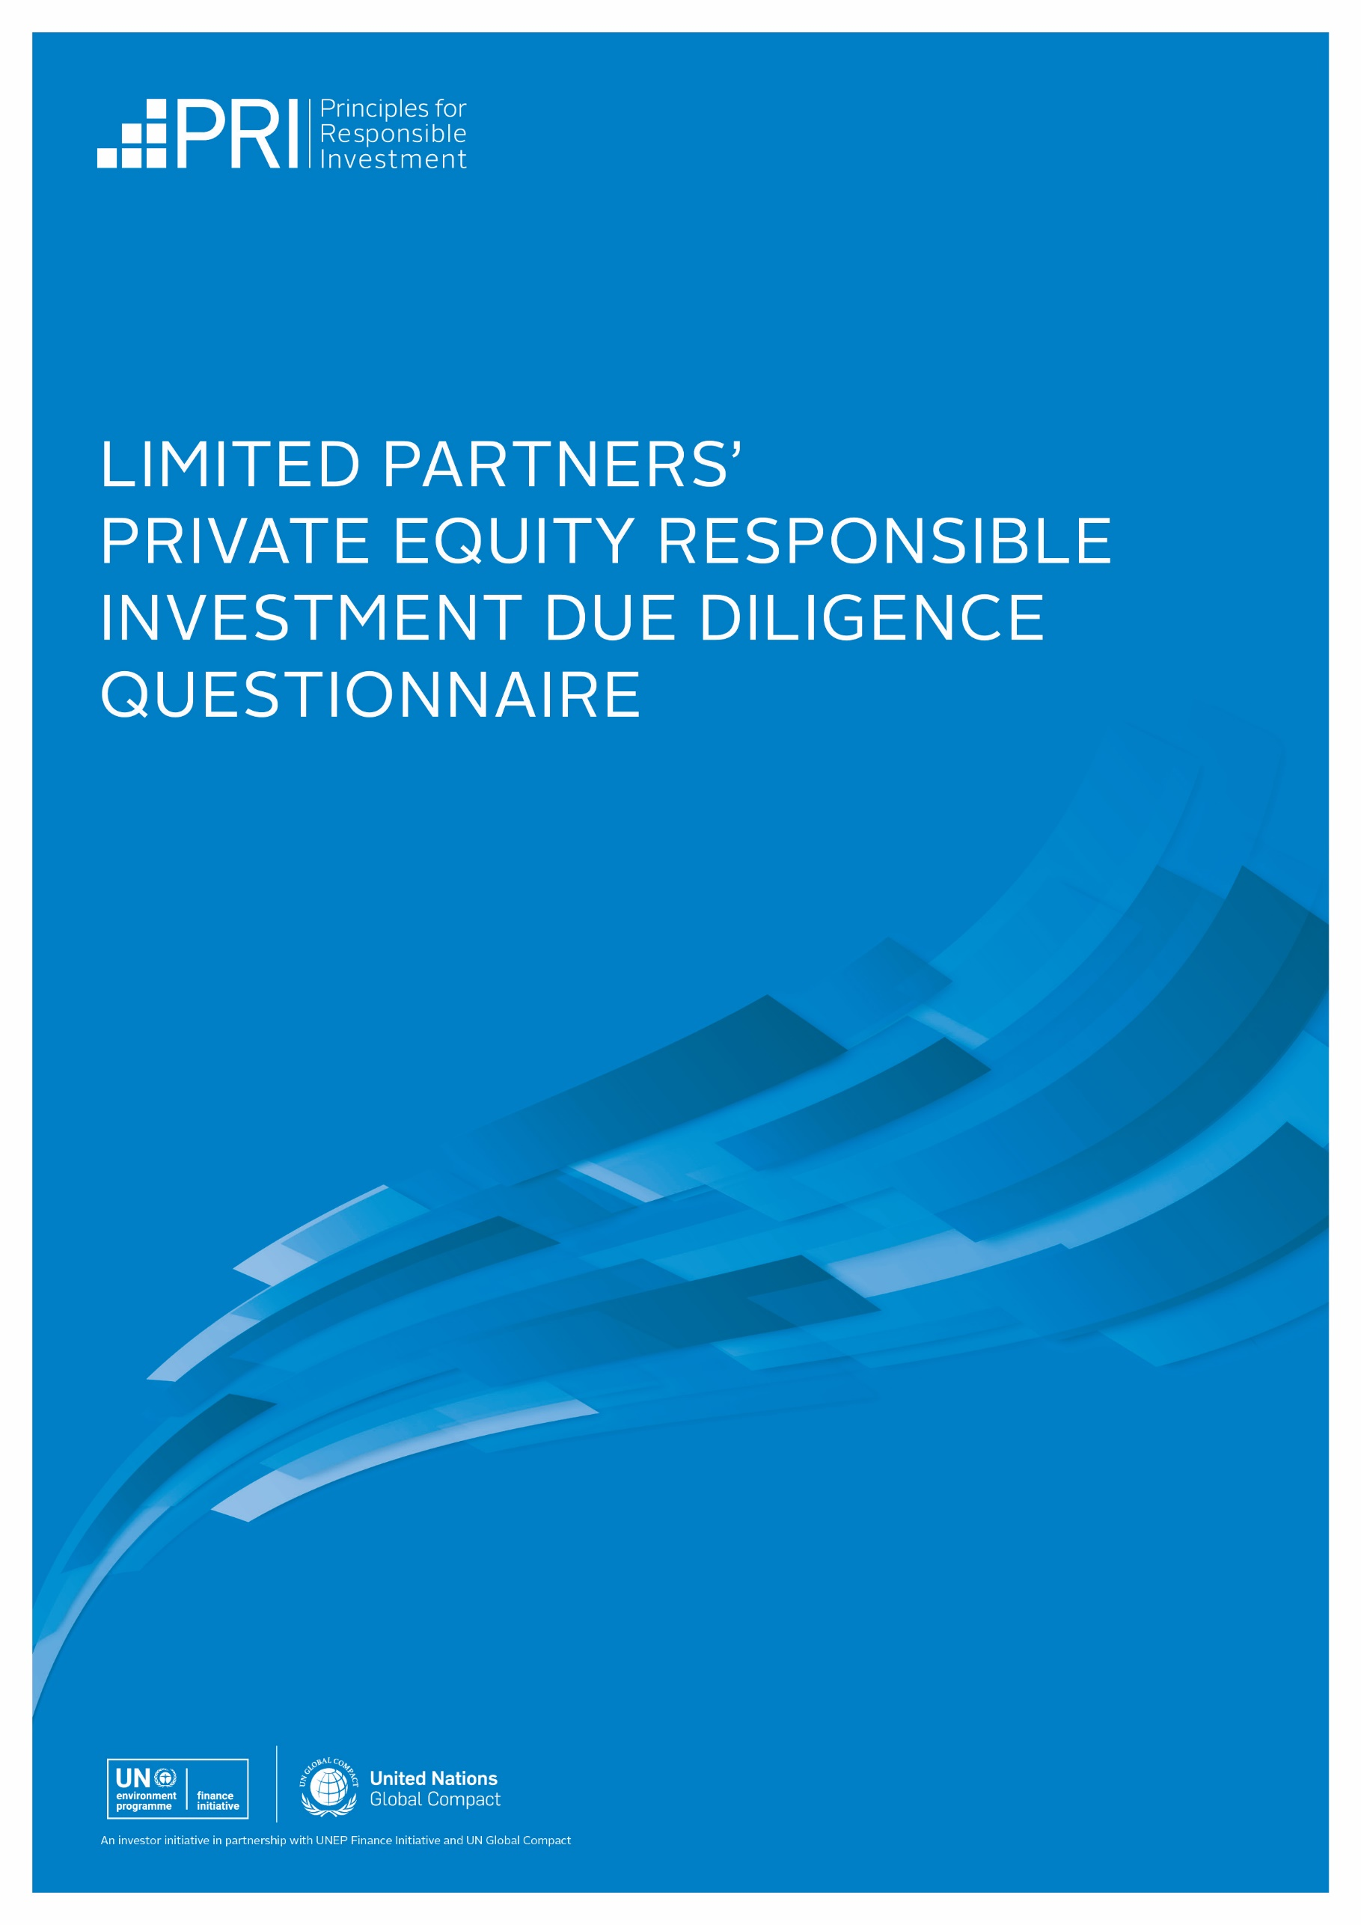

ddq questions

Policy

Understanding your ESG-related policies, governance, and oversight.

  - [PGS 1, PE 1] Do you have a responsible investment policy?
  - What international standards, industry (association) guidelines, reporting frameworks, or initiatives that promote responsible investment practices have you committed or contributed to?
[PGS 17,18] Ensure that any relevant commitments to standards, guidelines, frameworks, or initiatives relating to climate change are also included.
  - [PGS 11, 11.1, 12] How are (i) oversight responsibilities and (ii) implementation responsibilities for ESG incorporation structured within your organisation?
Please include any relevant discussion around how the management and oversight of climate-related risks and opportunities are structured within your organisation.
  - [PGS 13, 14] To what extent, if any, are ESG objectives incorporated into performance reviews and compensation mechanisms at your firm?
  - How do you equip your investment professionals and other staff to understand and identify the relevance and importance of ESG risks and opportunities in investment activities?

Fundraising

Establishing your ESG commitments within fund documentation.

  - [PE 2] What formal ESG commitments have you made or do you plan to make in the Limited Partnership Agreement (LPA), side-letters, or other constitutive fund documents?

pre-investment

Understanding how you identify material ESG risks and opportunities in your investments.

  - [PE 3, 3.1, 5] How do you conduct (i) ESG materiality analysis for potential investments and (ii) due diligence on potentially material ESG risks and opportunities?
[PGS 41, 41.1, 43, 44] Please include any relevant discussion around which frameworks and tools you use in due diligence to identify and assess climate transition and physical/adaptation risks and opportunities, including the use of scenario analysis.

  - [PE 4] How do ESG risks and opportunities affect the selection of your investments?
[PGS 41.1, 44] Please include any relevant discussion around how climate-related risks and opportunities affect your investment strategy or investment selection.
  - How are ESG risks and opportunities reported to, considered, and documented by the ultimate decision-making body, such as the investment committee?
3.4 How are ESG-related considerations integrated into deal documentation such as Shareholders' Agreements during deal structuring?

post-investment

Understanding how you contribute to your portfolio companies' ESG risk mitigation and value creation efforts.

  - [PE 8, 11] Do you create ESG-specific value creation plans or incorporate ESG issues into regular value creation and/or 100-day plans?
  - [PE 12, 12.1] How do you ensure that adequate ESG-related competence and resources exist at the portfolio company level?
  - How do you use your board seats or interaction with the board to monitor, influence, and incentivise the portfolio company's management of ESG risks and opportunities?
[PGS 41.1, 44] Ensure that any relevant discussion around the management of climate-related risks and opportunities is also included.
  - [PE 9] How do you contribute to the management of material ESG-related risks and opportunities during the holding period of your investments?
[PGS 41.1, 44] Please include any relevant discussion around the management of climate-related risks and opportunities.
  - [PE 6, 6.1] Do you monitor and track ESG key performance indicators (KPIs) for your investments?
[PGS 45] Please include a discussion of any climate physical or transition risk-related metrics.
  - [PE 7, 7.1] How do you use the identified ESG KPIs?
[SO 2, SO 3] Please include a discussion of KPIs related to climate change risks and opportunities.
  - [PE 13] How do you incorporate ESG considerations into preparations for exit?
  - How do you seek to determine whether your approach to ESG risks and opportunities has affected your investments' financial performance?
  - [PGS 47, 47.1, 47.2] Do you identify sustainability outcomes (the positive and negative real-world outcomes) related to investees’ operations, products and services?

reporting & disclosure

Understanding how LPs can monitor your ESG performance and ensure the fund is operating within agreed-upon policies and practices, including disclosing material ESG incidents.

  - [PE 14] How do you report and evidence progress on ESG performance, including data and targets, to LPs?
[PGS 45, 46] Please include a discussion relevant to climate change risk metrics and targets.
  - Is the management of ESG risks and opportunities included on your Limited Partners Advisory Committee and Annual Investor Meeting agenda?
  - What is your approach to managing material ESG incidents and disclosing them to your limited partners?

climate change

  - How do you measure and report the greenhouse gas (GHG) emissions associated with your investments?
  - Describe any climate commitments or targets your firm has made, or actions your firm employs, to assess and address climate-related risks and opportunities not otherwise covered in this document.
Ensure that, if relevant, you have responded to the guidance on climate-related risks and opportunities above in questions 1.2, 1.3, 3.1, 3.2, 4.3, 4.4, 4.5, 4.6 and 5.1, and add any further discussion that might be relevant here. If you have not disclosed any climate-related information, please explain why not.
  - If you have reported in line with the TCFD recommendations, please provide a copy of your TCFD report.

ADDITIONAL INFORMATION

  - If applicable, describe how your approach to ESG incorporation addresses specific ESG topics or practices not otherwise covered in this document.
  - How do you manage your management company's (i.e. your own business') internal ESG risks and opportunities?
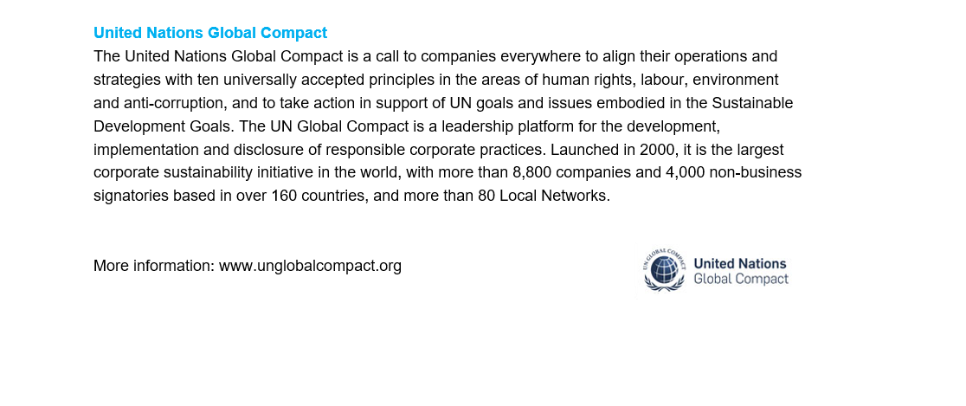
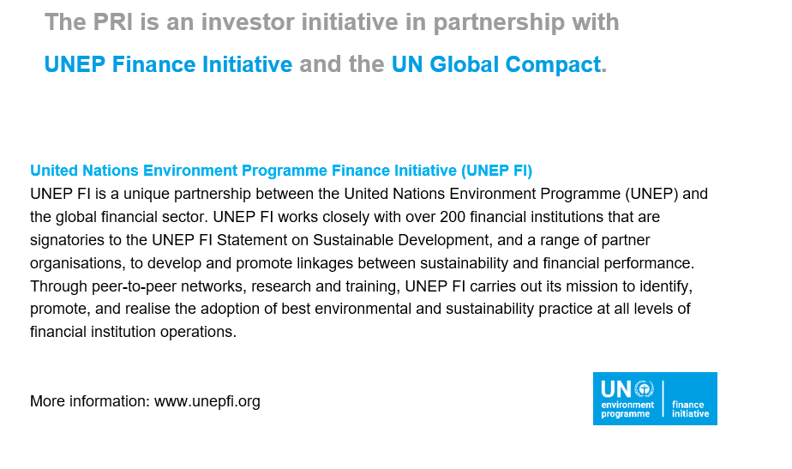
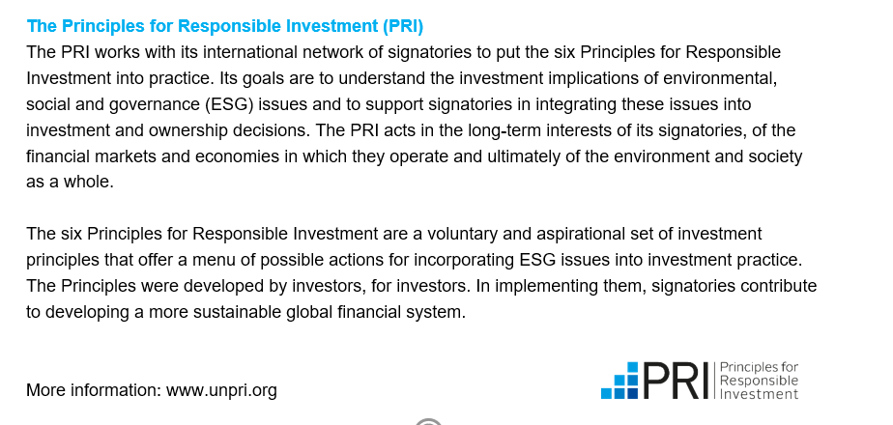
If you are completing this PRI DDQ as a standalone document outside of the ILPA DDQ, please include a separate response to the Diversity, Equity and Inclusion section of the ILPA DDQ and ILPA's Diversity Metrics Template. These can be found at https://ilpa.org/due-diligence-questionnaire/

Sustainability outcomes are the intended and unintended, positive and negative effects that the businesses in which you invest have on the world around them. Examples of negative outcomes include biodiversity loss resulting from construction in an open space, human rights violations linked to dual-use technology, stress on water systems due to high water consumption. Examples of positive outcomes include reduction of waste through circular economy initiatives, upskilling programs successfully retraining employees for the digital economy, development of green products or services (with evidence of positive sustainability impact), inclusive products and services that address issues of systemic racism.

